6. Project Testing Phase
Objective

To verify that the Auto Ticket Classification flow works correctly for different types of support tickets and produces the expected classification and assignment results.

Testing Activities

- Create test tickets with different issue descriptions.
- Verify that the Flow Designer trigger executes correctly.
- Check whether the correct condition is selected.
- Verify the assigned ticket category.
- Verify the assigned support group.
- Check whether the ticket is updated correctly.
- Test multiple ticket categories.
- Test tickets that do not match the predefined conditions.
- Identify and correct configuration errors.

Test Cases

Test Case| Input| Expected Result
TC01| Password/Login issue| Access/Account category
TC02| Laptop/Printer issue| Hardware category
TC03| Application issue| Software category
TC04| Internet issue| Network category
TC05| Unmatched issue| Appropriate fallback handling

Expected / Actual Result

Each test ticket is checked to confirm that the classification and assignment produced by the flow match the expected result.

Validation

The following items are validated:

- Flow trigger execution
- Condition evaluation
- Category assignment
- Assignment group selection
- Ticket field update
- Flow completion
- Error or unmatched condition handling

Expected / Produced Output

The testing phase produces validated results showing whether the Flow Designer automation performs the expected ticket classification process.

Screenshots

Screenshot 1
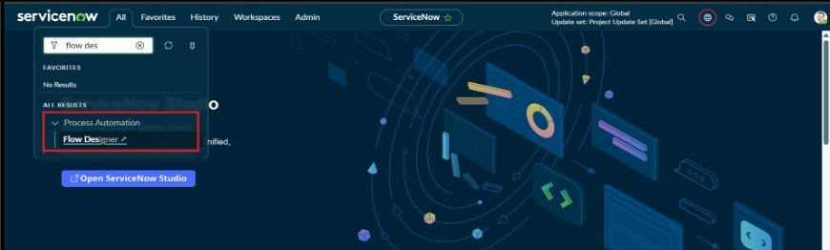
Screenshot 2
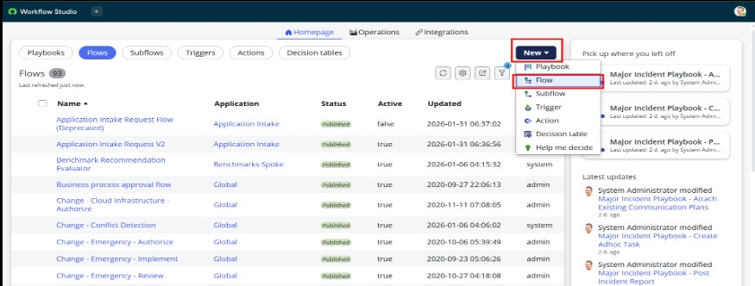

Screenshot 3
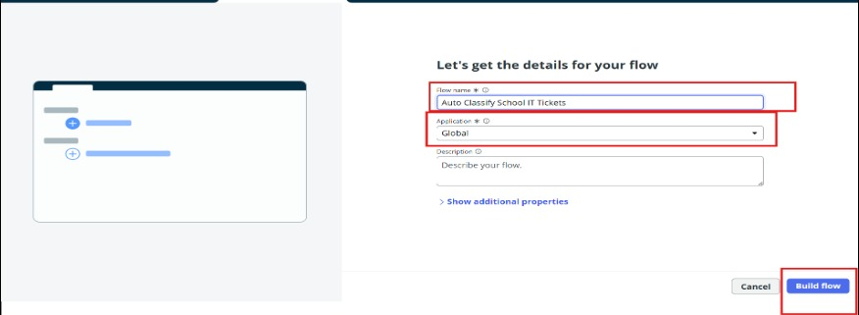
Screenshot 4
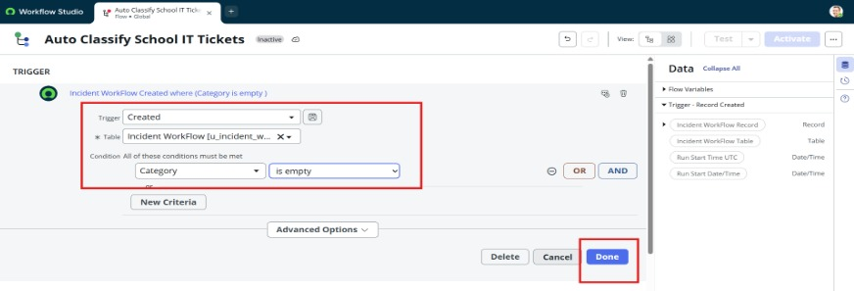

Data Flow Diagram

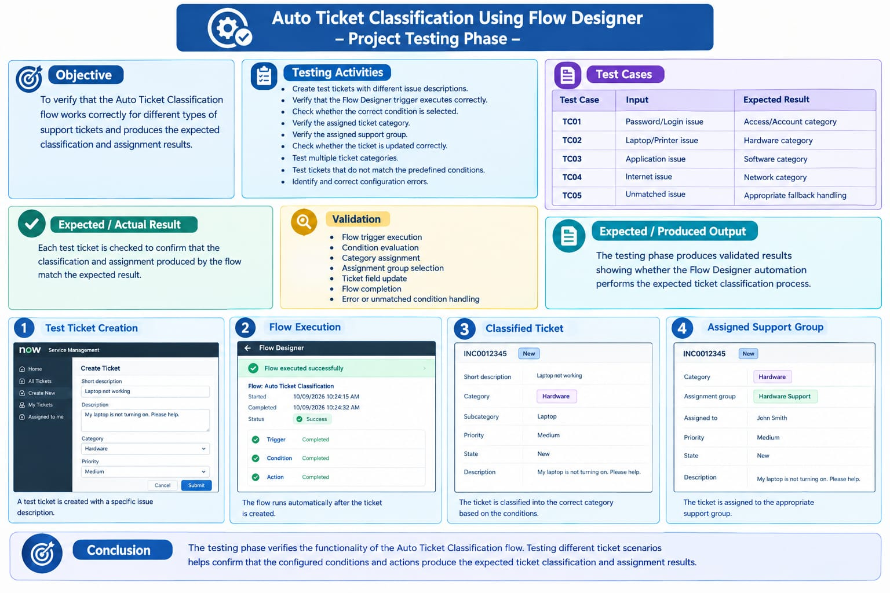
Conclusion

The testing phase verifies the functionality of the Auto Ticket Classification flow. Testing different ticket scenarios helps confirm that the configured conditions and actions produce the expected results.

